How-to get GIT into eclipse

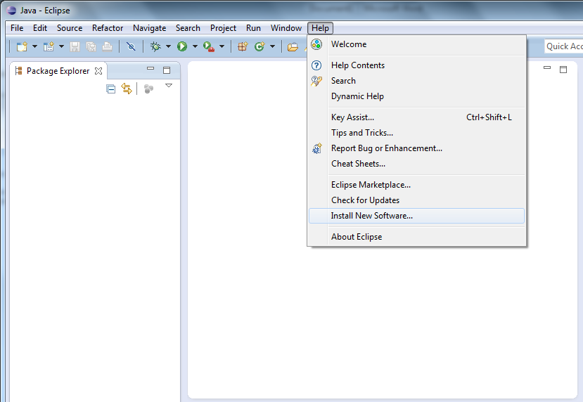

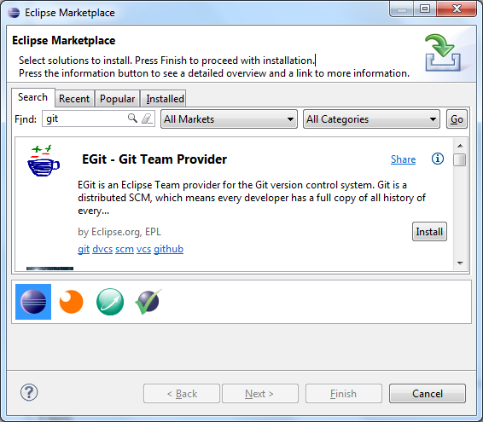

Select all, next, next, accept, finish, restart

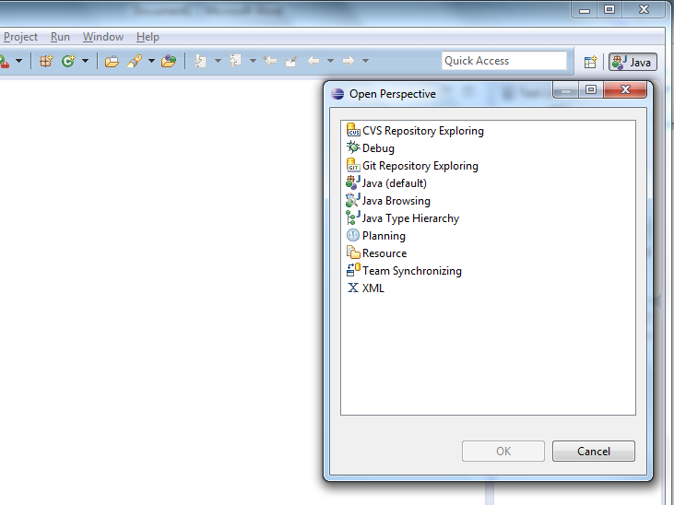

COPY THIS URL NOW!

<https://github.com/akkerman/SCJP-sessies.git>

Click  
Clonea Git repository

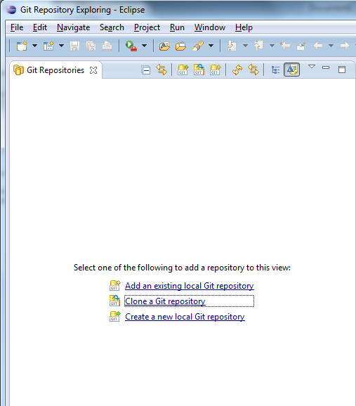

Stuff should be filled in automatically from the clipboard

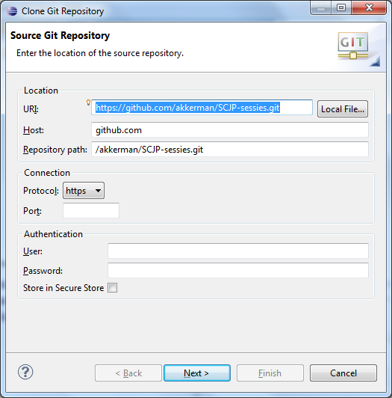

Next, Next, Finish

Import projects

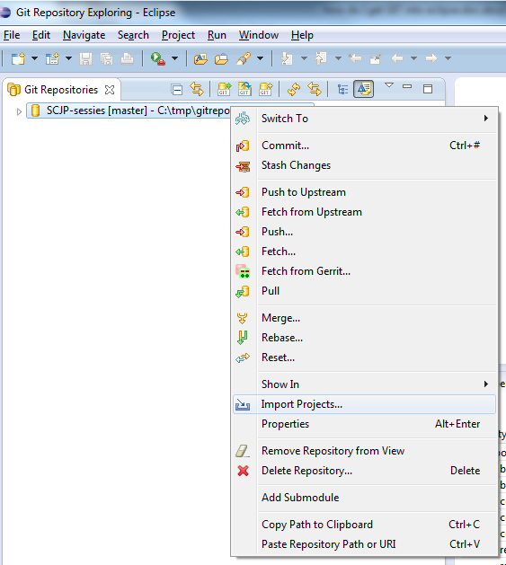

Next

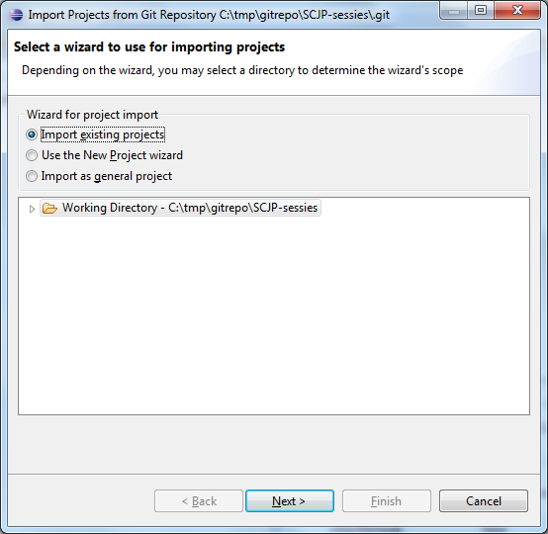

Finish

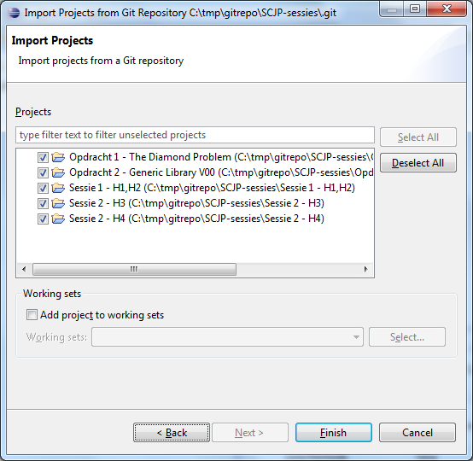

Congratulations

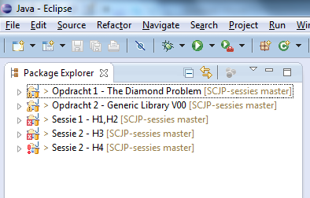

When and if there is an update, switch to GIT perspective.

Richt click the repository,

Fetch from upstream

Optionally, rebase